**Jenny Boynton**

**DSP 539**

**Research Paper (Redo)**

**Intro**

Background:

Meat is globally recognized as a prime source of protein within a human diet. Recent news and studies have questioned whether or not meat actually plays a positive role in the human diet. Different eating habits, cultural preferences and overall food trends may impact the quantity of meat consumed within countries. Different countries also consume different types of meat; for example, the United States does not traditionally consume sheep meat, while other countries such as New Zealand and Australia consume significant quantities of sheep meat (*Agricultural output - Meat consumption*). Wealth may also impact the amount of meat consumed; countries with higher gross domestic product (GDP) per capita have more of a fiscal opportunity to purchase meat products. Meat consumption on the basis of geography, type of meat, and time all potentially impact cardiovascular disease death rates.

Previous research:

A previous study was conducted to see if a combination of red meat and alcohol have negative impacts on human health at a macro and country level. This study produced results indicating that high levels of red meat consumption do appear to have a negative impact on life expectancy, more specifically in countries with higher incomes (Ranabhat, 2020). A second study explored the relationship of a low-to-no meat diet with life expectancy. This study showed that long term diets consisting of lower levels of meat may contribute to a longer life span (Singh, 2003). Another study was conducted on whether or not red and processed meat contribute to higher mortality levels, resulting in a positive relationship, especially for processed meat(Larsson, 2013). A different study analyzed mortality rates of vegetarians compared with meat-eaters, which concluded that “vegetarians have a lower risk of dying from ischaemic heart disease than non-vegetarians” (Key, 1998). Lastly, a European study was conducted to analyze the same relationship- between red meat, processed meat and mortality; finding again that processed meats have a positive association with mortality, in this case specifically due to cardiovascular disease and cancer (Rohrmann, 2013). With some studies implicating excess meat consumption in a shortened lifespan, seemingly from the resulting effects on heart health, we were curious whether there was a correlation between a certain type of meat, or diet, and this unfortunate result.

Study objective:

The objective of this research is to show the effect of different types of meat on death rates from cardiovascular disease. Cardiovascular disease is impacted by many variables, however the quality and type of food being eaten is one of the key contributors. Understanding how quantity and type of meat consumed can impact one’s potential for cardiovascular disease is key to understanding the best way to make decisions to potentially extend one’s life.

**Methods**

* **Assumptions:** 
  + All other dietary items consistent among populations
  + Quality of meat consistent among populations
* **Data**

Meat consumption data was imported as full indicator data from the Organisation for Economic Co-operation and Development (OECD) web page. Data on death rates from cardiovascular disease was imported from the Our World in Data web page. Data on life expectancy, GDP per capita, and population was used from the gapminder package in Rstudio, which can also be found in its raw form on the gapminder website (<http://www.gapminder.org/data/>). All three of these data sets each included numerous countries over differing time spans.

* **Meat Consumption Data**

The meat consumption data originally contained columns labeled: location, indicator, subject, measure, frequency, time, value and flag codes. The location column contained country codes rather than country names for 35 countries and 3 non countries (WLD,OECD, BRICS). Indicator was the same for every row: MEATCONSUMP. Subject indicated the type of meat being consumed and was divided into four categories: poultry, beef, sheep and pig. Measure was divided into two measurement types: KG_CAP, “kilograms of retail weight per capita” and THND_TONNE, “thousand tonnes of carcass weight (except for poultry expressed as ready to cook weight)”(*Agricultural output - Meat consumption*). Frequency was the same for every row: A. Time was from 1990-2026, conducted yearly, with actual data up to 2020 and forecasted data until 2026. Value was the actual measured data measured to the thousandth decimal. Lastly, Flag codes again had the same NA value for every row.

* **Cardiovascular Disease Mortality Rate Data**

The cardiovascular disease death rate data contained four columns: Entity, Code, Year and Deaths - Cardivascular diseases - Sex: Both - Age: Age-standardized (Rate). The Entity column contained 231 countries. The code column contained the matching country codes of the countries. The year column spanned from 1990-2017 conducted yearly. Lastly, the Deaths - Cardivascular diseases - Sex: Both - Age: Age-standardized (Rate) column contained the annual number of deaths from cardiovascular diseases per 100,000 people rounded to the ten-thousandth.

* **Gapminder Package**

The gapminder package consisted of six columns: country, continent, year, lifeExp, pop and gdpPercap. Country had 142 country names. Continent had 5 groups: Asia, Europe, Africa, Americas and Oceania. Year was from 1952-2007 conducted at five year intervals. LifeExp was recorded to the thousandth decimal place. Population was recorded as whole numbers. GdpPercap was to the ten thousandth decimal place.

* **Data Analysis:**

All three datasets were imported into RStudio, and analyzed using several packages and libraries to conduct exploratory research (e.g. “gapminder” and “skimr”). Once the libraries were loaded, the data on meat consumption, cardiovascular disease and the gapminder data were imported, and data were tidied. Plots 1–4 were created to visualize the datasets. The first three plots graphed Per Capita Consumption (lbs) over time, by country—Plot 1 shows meat type separated into four categories, Plot 2 combines all meat types into one category, and Plot 3 separates the graph by continent with a different color key to make it easier to observe. Plot 4 graphed Cardiovascular Disease Death Rates over time, by country.These two datasets were then combined to eliminate countries that did not have corresponding data for both categories (i.e. did not contain information on both the per capita meat consumption and cardiovascular disease related mortality). A new graph was then created to compare the meat consumption data on the x-axis with the cardiovascular mortality rate data on the y-axis, separated by country. A linear model was created to further explore this graph. Plot 6 also explored the meat consumption data on the x-axis with the cardiovascular mortality rate data on the y-axis, separated by country however it divided the data into two separate graphs based on the death rate from cardiovascular disease—with the larger half being labeled “high” and the smaller half being labeled “low.” The types of meat were then further analyzed to see which contributed to the coefficient.

Plot 7 was a manipulation of Plot 6 but divided even further into quarters labeled “high,” “high-medium,” “low-medium,” and “low.” The types of meat were then further analyzed to see which contributed to the negative coefficient. Plots 8 & 9 also divided the data into percentages, however it was based on meat consumption rates instead of cardiovascular death rates. Plot 8 was divided in half, while plot 9 was divided into quarters. Plot 10 continued to look at the meat consumption data on the x-axis with the cardiovascular mortality rate data on the y-axis, separated by country, however it was divided based on each country’s GDP per capita using the data provided from the gapminder package. Multiple linear models were created to further explore each of the aforementioned graphs.

**Results**

Plots 1-4 observed individual datasets as a time series. The first plot showed that most countries saw an increase in poultry consumption over time, however no other type of meat seemed to follow an obvious pattern. The second plot showed that there was possibly a slight upward trend in meat consumption in most countries over time and the third graph confirmed that pattern. The fourth plot showed a general downwards trend from cardiovascular disease over time. This decrease in deaths from cardiovascular disease can likely be explained by advances in modern medicine and technology. Plot 5, which looked at cardiovascular mortality rate as a function of consumption quantity, indicates a statistically significant relationship as inferred by the p-value[fig. 1a]. In addition, it shows an adjusted R-squared that tells me that the graph is only approximately 5% fitted to the regression line, meaning 95% of the variability is unexplained. Looking at the graph[fig. 1] this makes sense because the values are all over the place and do not appear to follow a single linear pattern. The coefficient is slightly negative meaning that generally as consumption of meat goes up, the mortality rate goes down. This makes sense considering the original patterns of each dataset; meat consumption trended up and mortality rates trended down, so the expectation would be something close to a horizontal line with a possible negative or positive lean.

Figure 1

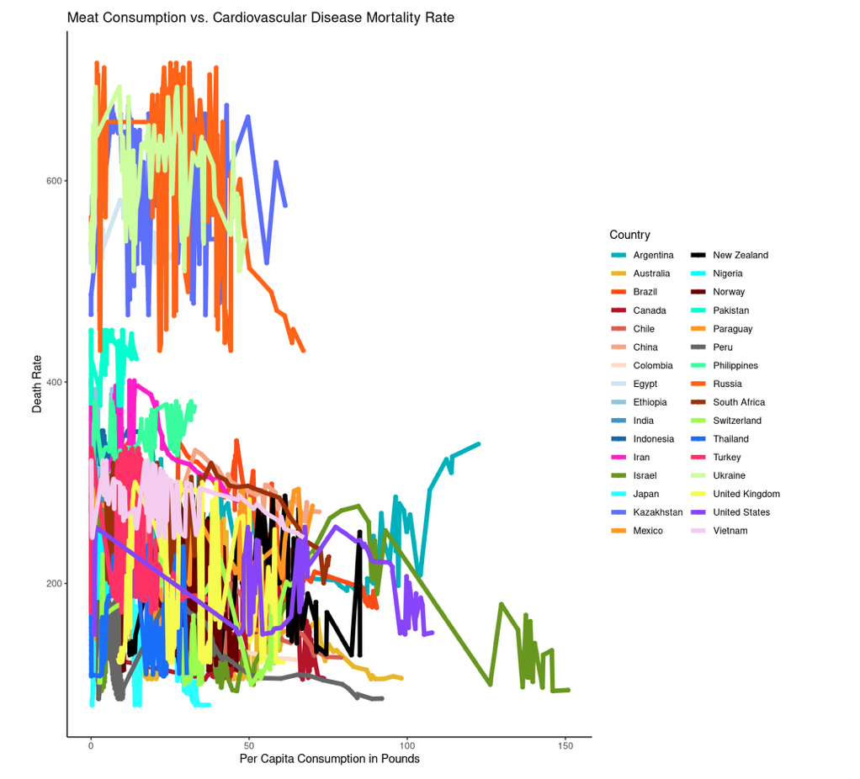

Figure 1a

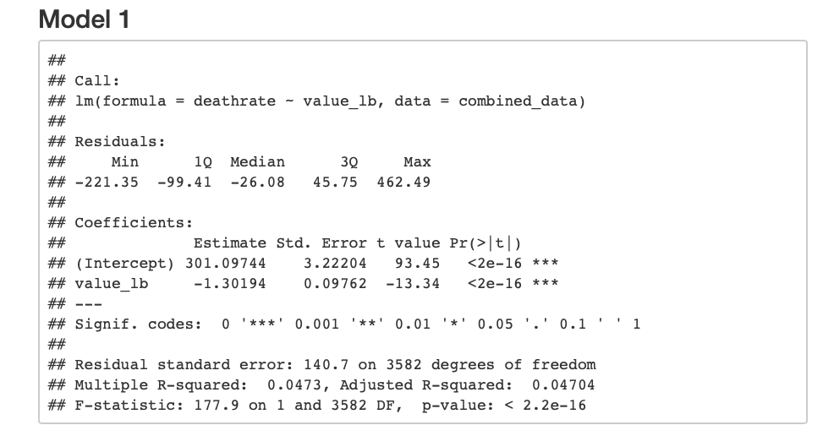

Figure 2

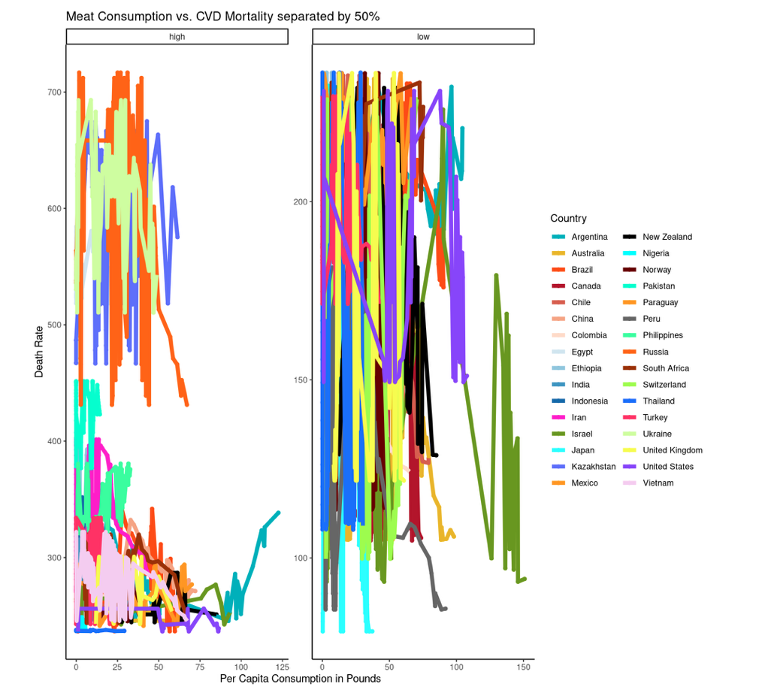

Figure 2a

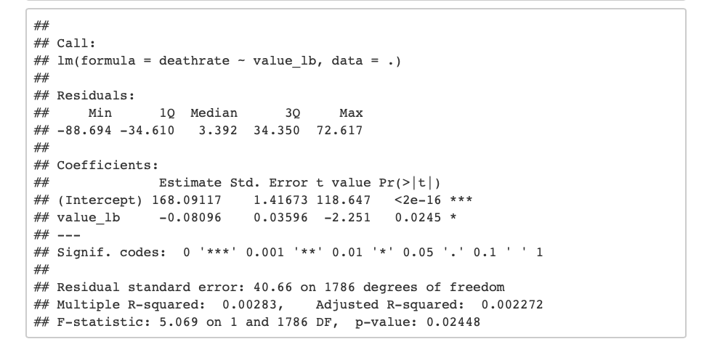

Looking at Plot 6[fig. 2], the higher 50% p-value[fig. 2a] indicated it was not statistically significant, however the lower 50% p-value did indicate it was statistically significant. The r-squared value is not very helpful, which makes sense observing the graphs. In this case, the lower 50% had a slightly negative coefficient meaning that as meat consumption increased, mortality rate again went down.

Figure 3

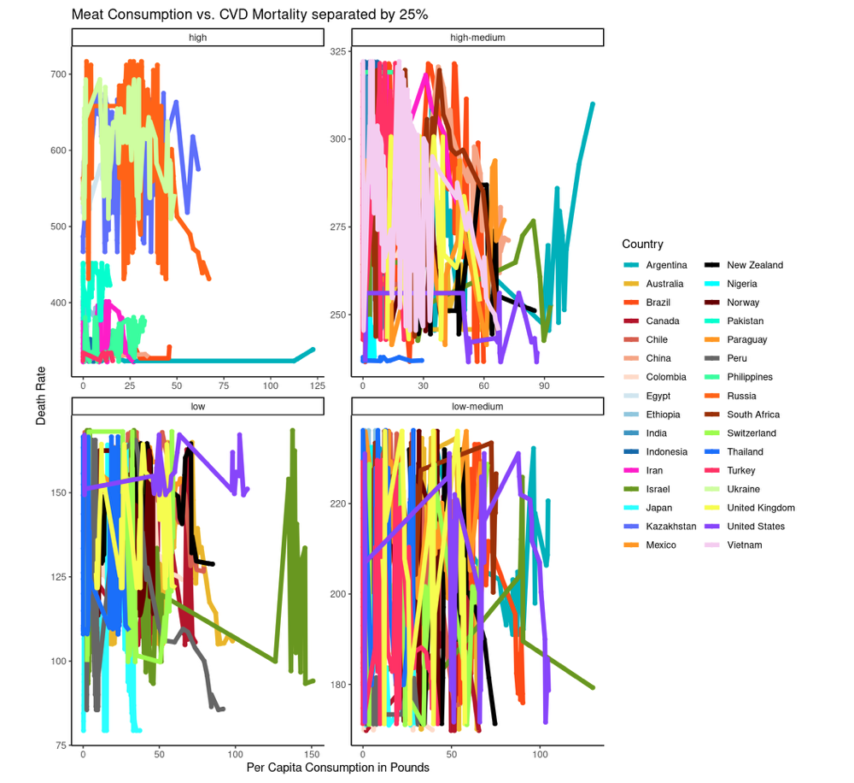

Figure 3a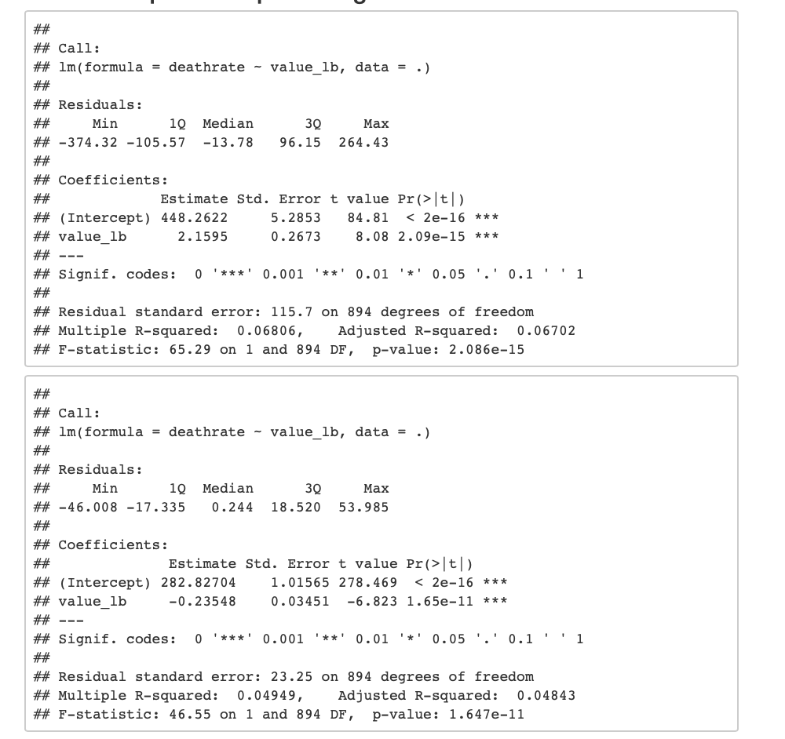

Figure 3b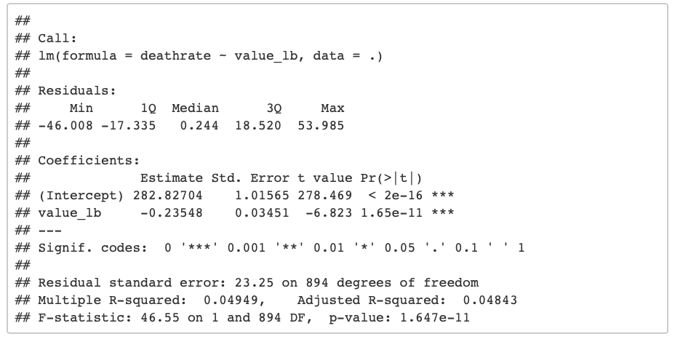

Looking at plot 7[fig. 3], both the high[fig. 3a] and high-medium[fig. 3b] models had p-values that indicated they were statistically significant, while low-medium and low did not. The high value graph has a slightly positive coefficient, indicating that for countries with high mortality rates, there is also high meat consumption rates. Whereas, on the other hand, the high medium graph had a slightly negative coefficient indicating the opposite trend; countries with medium high mortality rates are not eating high levels of meat.

Figure 3c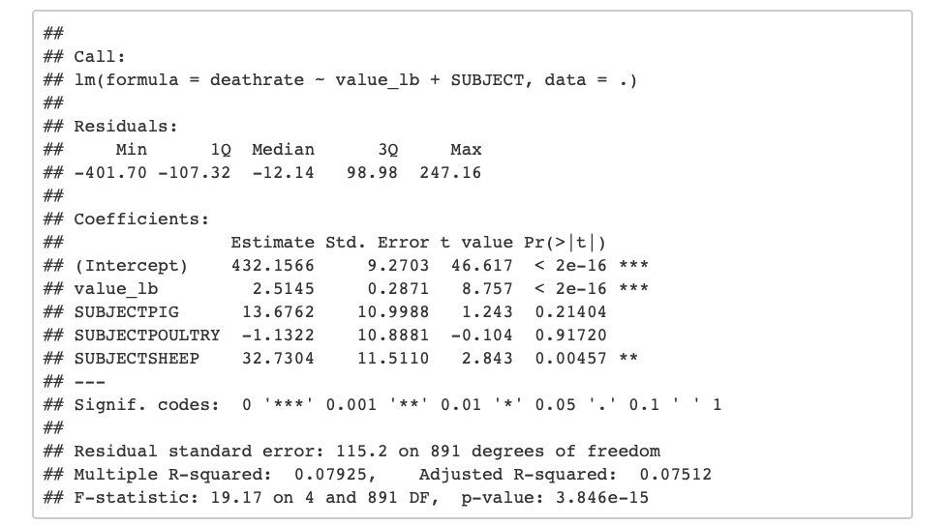

Figur3 3d

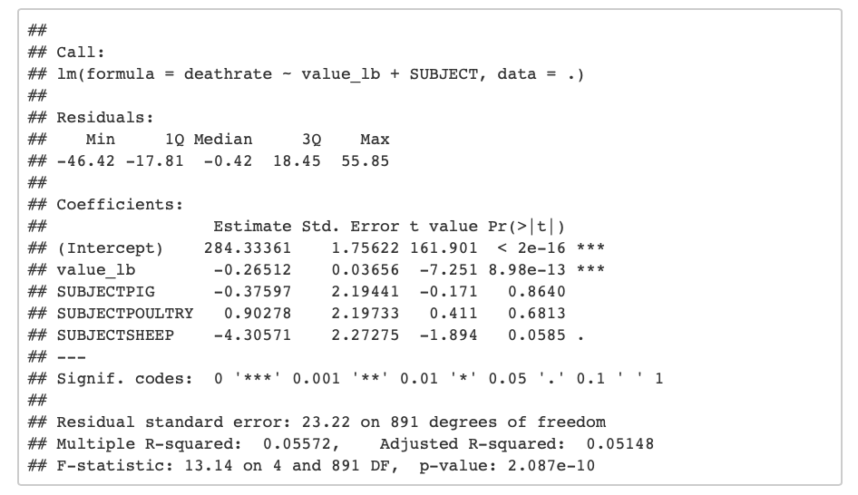

After further exploration into which type of meat contributed to the negative, the p-value maintains that both are statistically significant, and beef, pig, and predominantly sheep all have positive coefficients for the high model[fig. 3c] indicating higher levels of consumption when mortality rates are higher. Poultry, on the other hand, has a negative coefficient so as meat consumption increases, mortality rates decrease.. The high-medium graph model results[fig. 3d] was the reverse of the high results; with beef, pig, and sheep all having negative coefficients, while poultry was the only meat type with a positive coefficient.

Figure 4

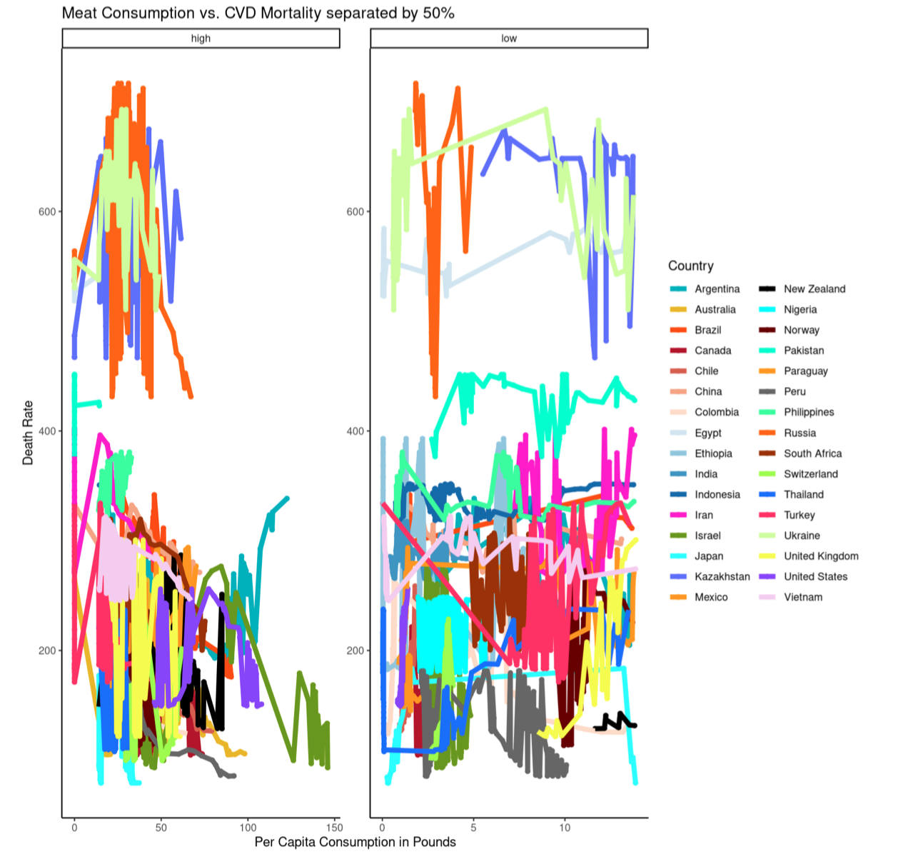

Figure 4a

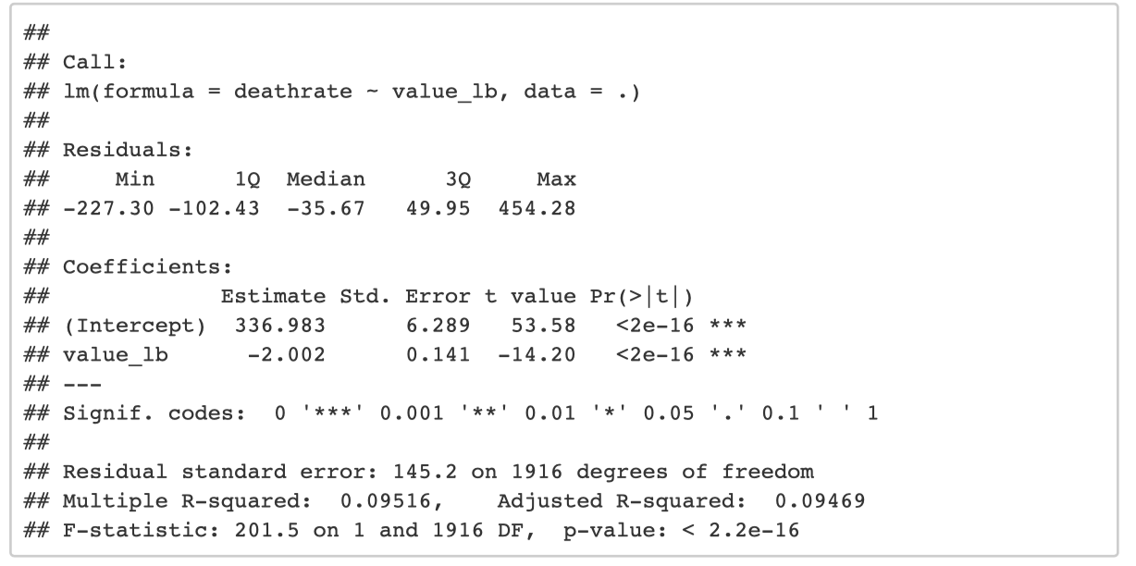

Figure 4b

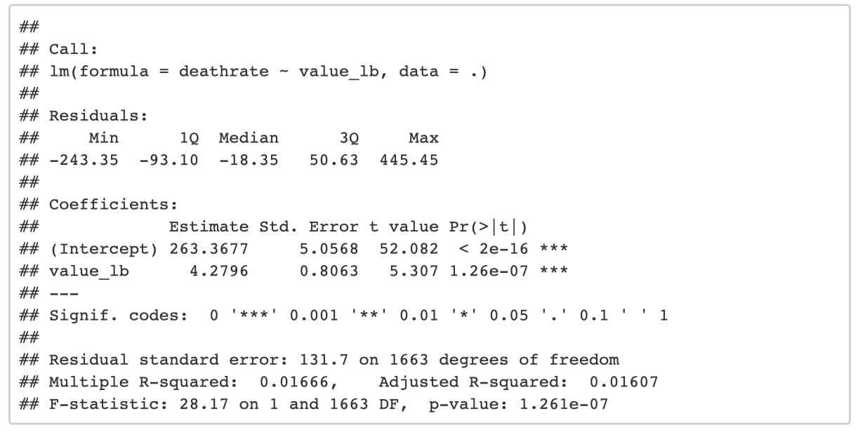

Looking at plot 8[fig. 4], both the high[fig. 4a] and low[fig. 4b] models had p-values that indicated they were statistically significant. The high value graph has a negative coefficient, indicating that for countries with low mortality rates, there are high meat consumption rates. Whereas, on the other hand, the low graph had a positive coefficient indicating the opposite trend; countries with high mortality rates are eating high levels of meat. The r-squared values show a complete lack of explained variability which makes sense when observing the graphs.

Figure 5

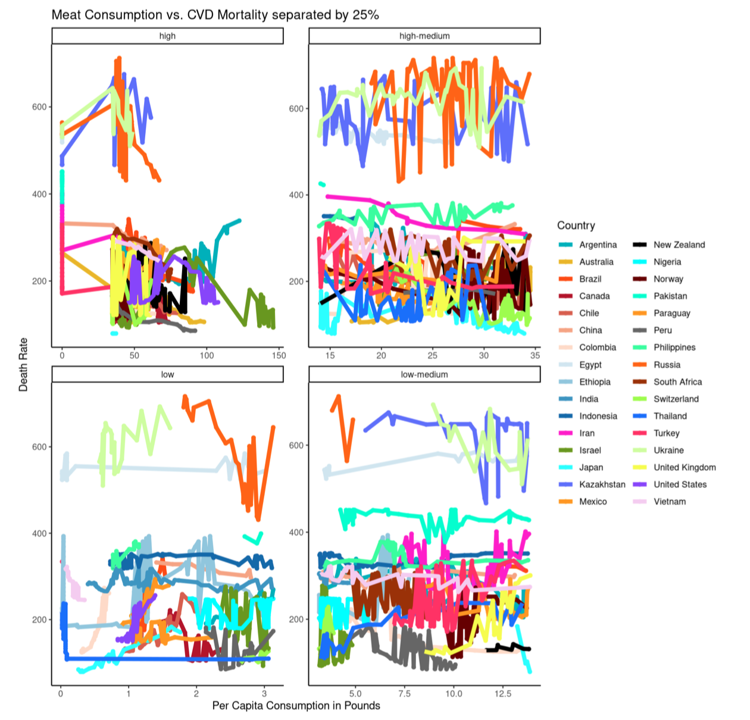

Figure 5a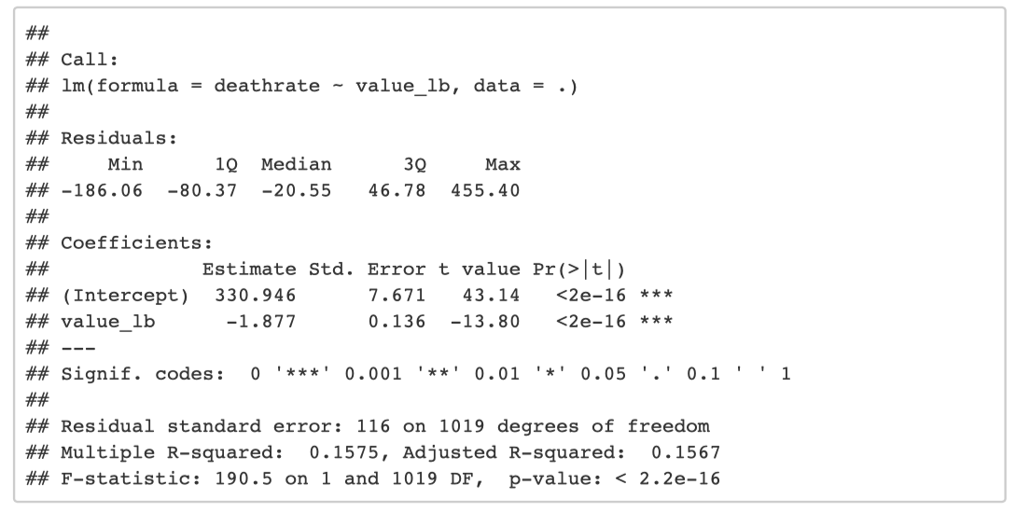Figure 5b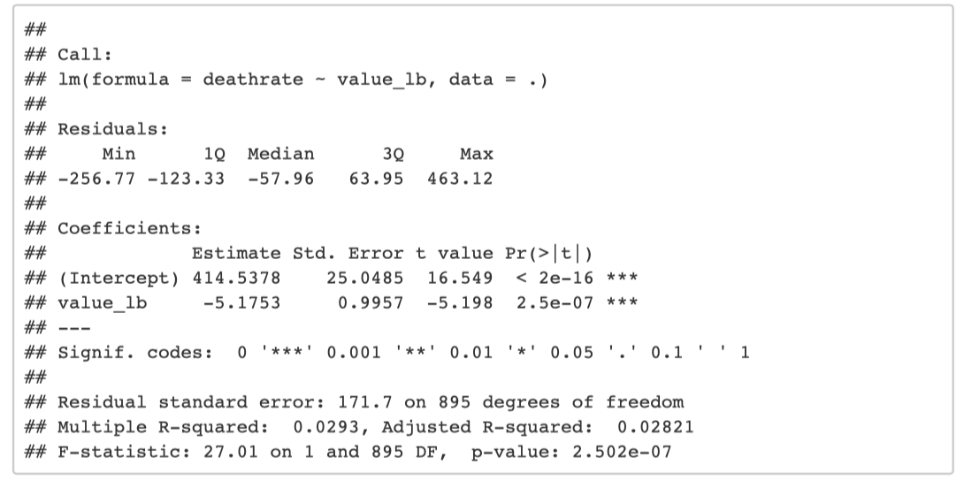Figure 5c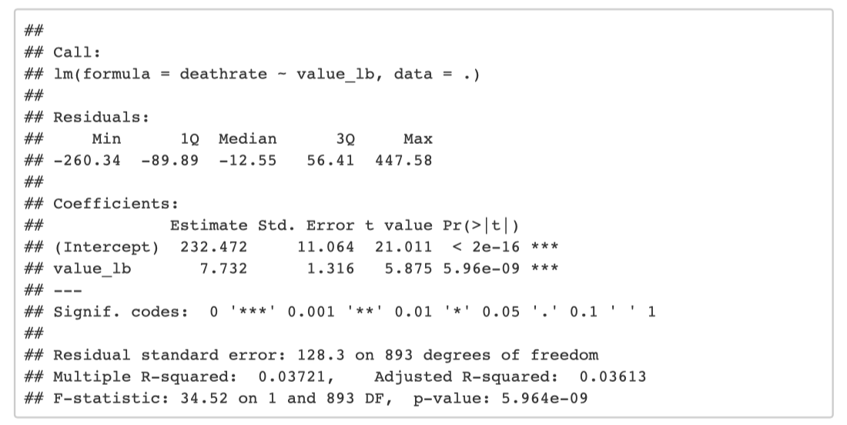

Looking at plot 9[fig. 5], the high[fig. 5a], high-medium[fig. 5b] and low-medium[fig. 5c] models had p-values that indicated they were statistically significant. The high and high-medium value graphs have negative coefficients, indicating that for countries with lower mortality rates, there are high meat consumption rates. Whereas, on the other hand, the low-medium graph had a positive coefficient indicating the opposite trend; countries with higher mortality rates are eating higher levels of meat.

Figure 6

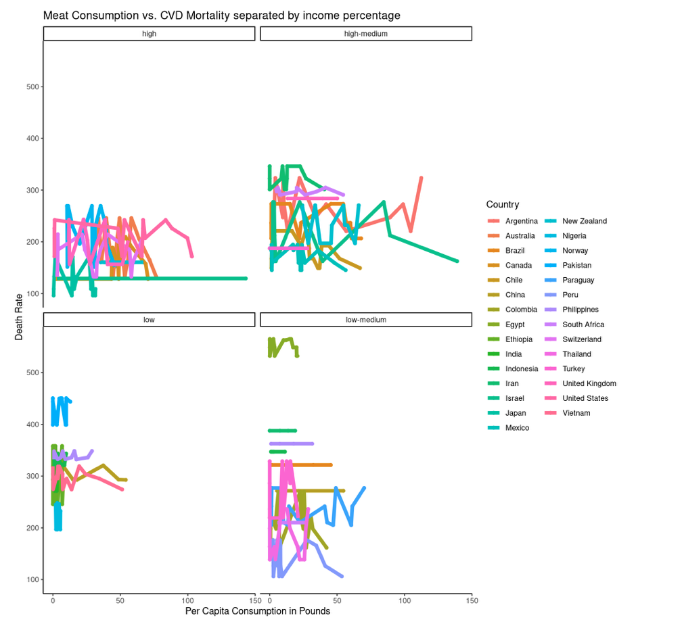

Figure 6a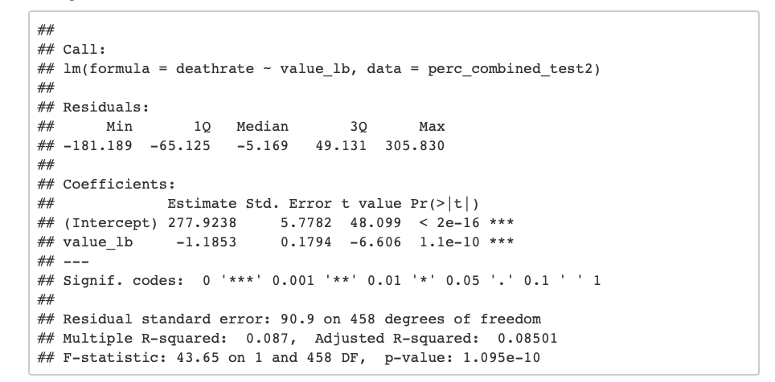

Looking at plot 8[fig. 4], the p-value indicates statistical significance and the coefficient is slightly negative. The adjusted r-squared is again not explanatory for this graph. This indicates that as meat consumption increases, mortality decreases. To better understand the influence of each type of meat, the data was further explored.

Figure 6b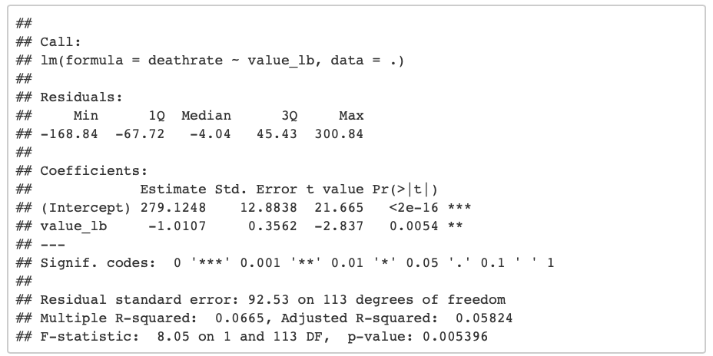Figure 6c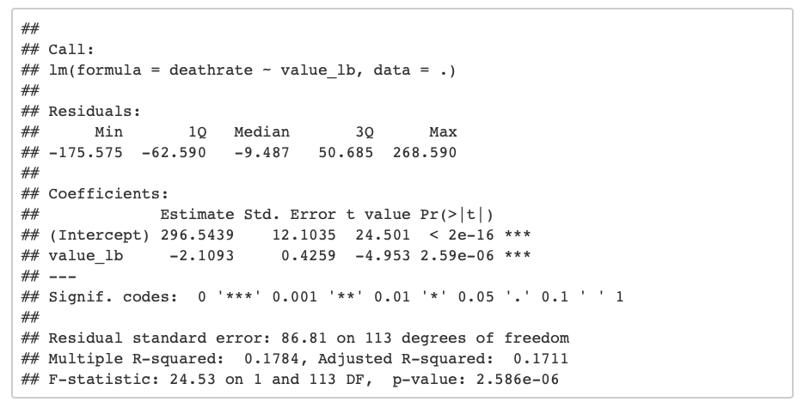Figure 6d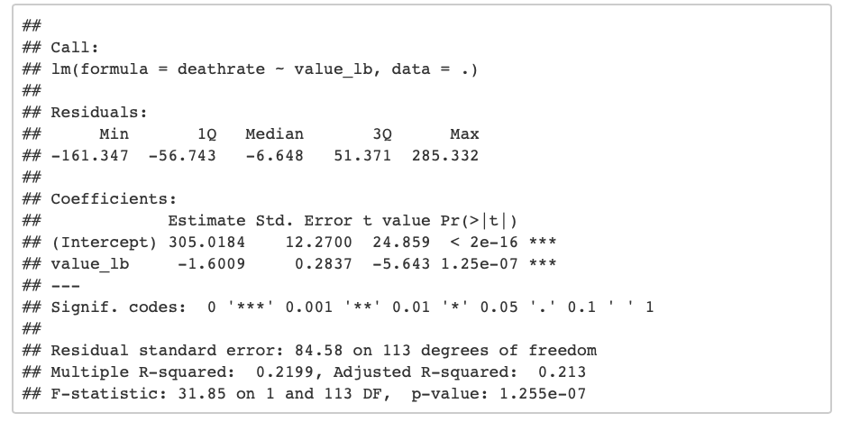

This further exploration showed p-values that indicated that beef[fig. 4b], pig[fig. 4c], and poultry[fig. 4d] were all statistically significant, while sheep was not a statistically significant variable. All of the coefficients were slightly negative indicating that as meat consumption increases, death rates from cardiovascular disease decrease.

**Discussion**

The results of this data exploration indicated that generally as meat consumption increases, mortality rates trend slightly down, specifically for beef, pig, and sheep. This is likely explained by the fact that an increase in income allows for higher levels of meat consumption alongside greater access to medical care and resources. When observing the graph divided in half by death rate, the lower half did indicate statistical significance and confirmed the initial negative trend, however, when observed in quarters, the high and high-medium categories had a p-value that indicated statistical significance and although the high-medium reconfirmed this trend, the high category contradicted it. There seemed to be a positive correlation at the highest level which, when explored further, the models revealed opposite results to the other data: beef, pig, and sheep all showed a positive coefficient. This indicates that at the highest interval of death rates, the more beef, pig and sheep consumed the higher the death rate increases; so, life expectancy decreases the more beef, pig and sheep consumed. This same contradiction occured when the data was divided by meat consumption rates; the low graph when the data was divided by 50% indicated a positive correlation and then the low-medium graph when divided by 25%. When divided by income bracket, the p-value indicates statistical significance and the coefficient is negative showing another overall decrease in the death rate with increased meat consumption. When broken down by subject this is reconfirmed as all show a negative correlation.

Thus, in conclusion, this study failed to produce results that showed any consistent trend overall. There are other variables affecting cardiovascular death rates that are not accounted for within this study(e.g. medical advancements, other diet/lifestyle choices, exercise, genetics, etc.). Between the variation in the results when exploring the data and the unaccounted for variables affecting cardiovascular death rates, it appears that a study with more controlled variables may be more effective for conclusive results, if such results exist.

**References**

*Agricultural output - Meat consumption - OECD Data*. theOECD. (n.d.). https://data.oecd.org/agroutput/meat-consumption.htm.

Key, T. J., Fraser, G. E., Thorogood, M., Appleby, P. N., Beral, V., Reeves, G., … McPherson, K. (1998, March 1). *Mortality in vegetarians and non-vegetarians: a collaborative analysis of 8300 deaths among 76,000 men and women in five prospective studies: Public Health Nutrition*. Cambridge Core. https://www.cambridge.org/core/journals/public-health-nutrition/article/mortality-in-vegetarians-and-nonvegetarians-a-collaborative-analysis-of-8300-deaths-among-76000-men-and-women-in-five-prospective-studies/9FF29F354456308D49006B5DCBBE5BF0.

Larsson, S. C., & Orsini, N. (2013, October 22). *Red Meat and Processed Meat Consumption and All-Cause Mortality: A Meta-Analysis*. OUP Academic. https://academic.oup.com/aje/article/179/3/282/103471?login=true.

Ranabhat, C. L., Park, M.-B., & Kim, C.-B. (2020, February 12). *Influence of Alcohol and Red Meat Consumption on Life Expectancy: Results of 164 Countries from 1992 to 2013*. MDPI. https://www.mdpi.com/2072-6643/12/2/459/htm.

Rohrmann, S., Overvad, K., Bueno-de-Mesquita, H. B., Jakobsen, M. U., Egeberg, R., Tjønneland, A., … Linseisen, J. (2013, March 7). *Meat consumption and mortality - results from the European Prospective Investigation into Cancer and Nutrition*. BMC Medicine. https://link.springer.com/article/10.1186%2F1741-7015-11-63.

Singh, P. N., Sabaté, J., & Fraser, G. E. (2003, September 1). *Does low meat consumption increase life expectancy in humans?* OUP Academic. https://academic.oup.com/ajcn/article/78/3/526S/4689992?login=true.